Government Polytechnic
Awasari (Khurd) Tal: Ambegaon, Dist.: Pune-410501



Department of Information Technology
2022-23
Sem-V
Micro-Project Part B
Advanced Java Programming
On
PIC PUZZLE GAME

Submitted by

Name of Student | Roll Number
Bangar Sarthak Nilesh | 22IF303
Shinde Amit Arun | 22IF341
Shinde Siddhi Tukaram | 22IF342
Walse Manali Rohidas | 22IF350

Under the Guidance of
Miss. P. C. Fafat

Department of Information Technology
GOVERNMENT POLYTECHNIC AWASARI (KHURD)
SEMESTER -5th 2022-23


CERTIFICATE
This is certify that Project report title “Pic Puzzle Game” submitted in the partial fulfillment of requirement for the award of the diploma in Information Technology by Maharashtra state Board of Technical Education as record of students own work carried out by them under my guidance and supervision at Government Polytechnic Awasari (Khurd), During the Academic year 2022-23.

Name of Student | Roll Number
Bangar Sarthak Nilesh | 22IF303
Shinde Amit Arun | 22IF341
Shinde Siddhi Tukaram | 22IF342
Walse Manali Rohidas | 22IF350

Place: Awasari (khurd)
Date: / /

(Dr. D. N. Rewadkar) (Miss. P. C. Fafat)
H.O.D Guidance

ACKNOWLEDGEMENT

We have great pleasure and sense of satisfaction in presenting this microproject report on “Pic Puzzle Game” as part of the curriculum of Diploma in Information Technology. Being novice in the field of designing and structuring in this micro-project on our own. We are very fortunate to be guided by people with vast and resourceful experience in their respective field of work.
We express our gratitude to our guide Miss. P. C. Fafat Ma’am.
(Lecturer, Information Technology Dept.) for her timely guidance, support and suggestions. We are also thankful for her sincere help and for making us available all the facilities of the department. Without her efforts and constant monitoring the micro-project and documentation would not have been completed. Also, we express our sincere thanks to Dr. D. N. Rewadkar Sir (HOD Information Technology ), Besides, we take this opportunity to express our sincere gratitude to the Principle Dr. D. R. Nandanwar Sir, (G.P.Awasari) for providing a good environment and facilities to complete this micro-project. We would also like to thank all my colleagues who have directly or indirectly guided and helped us in the preparation of this micro-project.

Bangar Sarthak
Shinde Amit
Shinde Siddhi
Walse Manali

PART B: -Advance Java Programming Report
Title:- Pic Puzzle Game

- Rationale
Picture puzzle is a Jigsaw game where players have to put the pieces to the right places. Players have to complete the puzzle in 60 and cute pictures to explore.

2.0 Aim/Benefits of the Micro-Project
This Micro-Project aims at
The main theme behind developing puzzle game using java is to provide a creative and competitive environment for the players who will use this system. The important part of this game, it's an online web application which can be access from anywhere using its domain name of by assigning IP address.

3.0 Course Outcomes Achieved

a) Design GUI using AWT and SWINGS
b) Develop program using event handler.

4.0 Literature Review
In every case, the puzzle-solver’s goal is to solve a particular mentally challenging problem or accomplish a particular mentally challenging task. Computer games are today an important part of most children’s leisure lives and increasingly an important part of our culture as a whole. Computer games are a growing part of our culture. The puzzle games have been too simplistic in comparison to competing video games.

5.0 Proposed Methodology
First of all we have to select a topic which Pic Puzzle Game. The teacher will assign one set of Micro Project and ask the student to create a report on Pic Puzzle Game.
We collected information about the topic using sources such as internet and books then we asked the subject teacher about the pic puzzle game on which we have a micro project and then we type the required part-A and done proper page set up and submitted to subject teacher.
After the setup of part- A we paper a report of pic puzzle game After finishing all the typing we arrange all the data in proper arrangement. We selected proper margin font, lay out, 4A size etc. at last we got the printouts of the micro- project and submitted to subject teacher.

5.0 Actual Resource Used

S.  No. | Name of Resource/material | Specifications | Qty. | Remarks
1 | Computer system | 8 GB ram I5 core | 1
2 | Operating system | Windows 11 | 1
3 | Software | JDK 8.1, | 1
4 | Printer | HP inject | 1

6.0 Source code

import java.awt.event.*;
import java.awt.*;
import javax.swing.*;
class picpuzzle2 extends JFrame implements ActionListener{
JButton b1,b2,b3,b4,b5,b6,b7,b8,b9,sample,starB;
Icon star;
Icon ic0=new ImageIcon("starB0.jpg");
Icon ic10=new ImageIcon("starB10.jpg");
Icon ic20=new ImageIcon("starB20.jpg");
Icon samicon1=new ImageIcon("main.jpg");
Icon samicon2=new ImageIcon("main2.jpg");
Icon samicon3=new ImageIcon("main3.jpg");
Icon ic1=new ImageIcon("1.PNG");
Icon ic2=new ImageIcon("5.PNG");
Icon ic3=new ImageIcon("2.PNG");
Icon ic4=new ImageIcon("7.PNG");
Icon ic5=new ImageIcon("4.PNG");
Icon ic6=new ImageIcon("6.PNG");
Icon ic7=new ImageIcon("8.PNG");
Icon ic8=new ImageIcon("9.PNG");
Icon ic9=new ImageIcon("3.PNG");

Icon ic11=new ImageIcon("12.PNG");
Icon ic12=new ImageIcon("13.PNG");
Icon ic13=new ImageIcon("16.PNG");
Icon ic14=new ImageIcon("11.PNG");
Icon ic15=new ImageIcon("14.PNG");
Icon ic16=new ImageIcon("19.PNG");
Icon ic17=new ImageIcon("17.PNG");
Icon ic18=new ImageIcon("15.PNG");
Icon ic19=new ImageIcon("18.PNG");

Icon ic21=new ImageIcon("24.PNG");
Icon ic22=new ImageIcon("25.PNG");
Icon ic23=new ImageIcon("21.PNG");
Icon ic24=new ImageIcon("27.PNG");
Icon ic25=new ImageIcon("23.PNG");
Icon ic26=new ImageIcon("29.PNG");
Icon ic27=new ImageIcon("28.PNG");
Icon ic28=new ImageIcon("22.PNG");
Icon ic29=new ImageIcon("26.PNG");

picpuzzle2(){

super("picture puzzle");

b1=new JButton(ic1);
b1.setBounds(10,80,100,100);
b2=new JButton(ic2);
b2.setBounds(110,80,100,100);
b3=new JButton(ic3);
b3.setBounds(210,80,100,100);
b4=new JButton(ic4);
b4.setBounds(10,180,100,100);
b5=new JButton(ic5);
b5.setBounds(110,180,100,100);
b6=new JButton(ic6);
b6.setBounds(210,180,100,100);
b7=new JButton(ic7);
b7.setBounds(10,280,100,100);
b8=new JButton(ic8);
b8.setBounds(110,280,100,100);
b9=new JButton(ic9);
b9.setBounds(210,280,100,100);
sample=new JButton(samicon1);
sample.setBounds(380,100,200,200);

JLabel l1=new JLabel("Sample:");
l1.setBounds(330,200,70,20);
JLabel l2=new JLabel("NOTE:: icon has power to swap with neighbour icon=>");
l2.setBounds(5,15,500,20);
JLabel l3=new JLabel("click sample picture to next puzzle");
l3.setBounds(380,320,200,20);
l3.setForeground(Color.red);

starB=new JButton(ic0);
starB.setBounds(330,5,50,50);
star=b9.getIcon();

add(b1);add(b2);add(b3);add(b4);add(b5);add(b6);add(b7);add(b8);add(b9);add(sample);add(l1);add(l2);add(starB);add(l3);
b1.addActionListener(this); b2.addActionListener(this); b3.addActionListener(this); b4.addActionListener(this); b5.addActionListener(this); b6.addActionListener(this); b7.addActionListener(this); b8.addActionListener(this); b9.addActionListener(this);
sample.addActionListener(this);
setLayout(null);
setSize(600,500);
setVisible(true);
setDefaultCloseOperation(JFrame.EXIT_ON_CLOSE);
}

public void actionPerformed(ActionEvent e){
if(e.getSource()==b1){
Icon s1=b1.getIcon();
if(b2.getIcon()==star){
b2.setIcon(s1);
b1.setIcon(star);
} else if(b4.getIcon()==star){
b4.setIcon(s1);
b1.setIcon(star);
}
}//end of if

if(e.getSource()==b2){
Icon s1=b2.getIcon();
if(b1.getIcon()==star){
b1.setIcon(s1);
b2.setIcon(star);
} else if(b5.getIcon()==star){
b5.setIcon(s1);
b2.setIcon(star);
}
else if(b3.getIcon()==star){
b3.setIcon(s1);
b2.setIcon(star);
}
}//end of if

if(e.getSource()==b3){
Icon s1=b3.getIcon();
if(b2.getIcon()==star){
b2.setIcon(s1);
b3.setIcon(star);
} else if(b6.getIcon()==star){
b6.setIcon(s1);
b3.setIcon(star);
}
}//end of if

if(e.getSource()==b4){
Icon s1=b4.getIcon();
if(b1.getIcon()==star){
b1.setIcon(s1);
b4.setIcon(star);
} else if(b5.getIcon()==star){
b5.setIcon(s1);
b4.setIcon(star);
}
else if(b7.getIcon()==star){
b7.setIcon(s1);
b4.setIcon(star);
}
}//end of if

if(e.getSource()==b5){
Icon s1=b5.getIcon();
if(b2.getIcon()==star){
b2.setIcon(s1);
b5.setIcon(star);
} else if(b4.getIcon()==star){
b4.setIcon(s1);
b5.setIcon(star);
}
else if(b6.getIcon()==star){
b6.setIcon(s1);
b5.setIcon(star);
}
else if(b8.getIcon()==star){
b8.setIcon(s1);
b5.setIcon(star);
}
}//end of if

if(e.getSource()==b6){
Icon s1=b6.getIcon();
if(b3.getIcon()==star){
b3.setIcon(s1);
b6.setIcon(star);
} else if(b5.getIcon()==star){
b5.setIcon(s1);
b6.setIcon(star);
}
else if(b9.getIcon()==star){
b9.setIcon(s1);
b6.setIcon(star);
}
}//end of if

if(e.getSource()==b7){
Icon s1=b7.getIcon();
if(b4.getIcon()==star){
b4.setIcon(s1);
b7.setIcon(star);
} else if(b8.getIcon()==star){
b8.setIcon(s1);
b7.setIcon(star);
}
}//end of if

if(e.getSource()==b8){
Icon s1=b8.getIcon();
if(b7.getIcon()==star){
b7.setIcon(s1);
b8.setIcon(star);
} else if(b5.getIcon()==star){
b5.setIcon(s1);
b8.setIcon(star);
}
else if(b9.getIcon()==star){
b9.setIcon(s1);
b8.setIcon(star);
}

}//end of if

if(e.getSource()==b9){
Icon s1=b9.getIcon();
if(b8.getIcon()==star){
b8.setIcon(s1);
b9.setIcon(star);
} else if(b6.getIcon()==star){
b6.setIcon(s1);
b9.setIcon(star);
}
}//end of if

if(e.getSource()==sample){
Icon s1=sample.getIcon();
if(s1==samicon3){
sample.setIcon(samicon1);
b1.setIcon(ic1);
b2.setIcon(ic2);
b3.setIcon(ic3);
b4.setIcon(ic4);
b5.setIcon(ic5);
b6.setIcon(ic6);
b7.setIcon(ic7);
b8.setIcon(ic8);
b9.setIcon(ic9);
star=b9.getIcon();
starB.setIcon(ic0);
}//eof if
else if(s1==samicon1){
sample.setIcon(samicon2);
b1.setIcon(ic11);
b2.setIcon(ic12);
b3.setIcon(ic13);
b4.setIcon(ic14);
b5.setIcon(ic15);
b6.setIcon(ic16);
b7.setIcon(ic17);
b8.setIcon(ic18);
b9.setIcon(ic19);
star=b6.getIcon();
starB.setIcon(ic10);
}//eof else
else{
sample.setIcon(samicon3);
b1.setIcon(ic21);
b2.setIcon(ic22);
b3.setIcon(ic23);
b4.setIcon(ic24);
b5.setIcon(ic25);
b6.setIcon(ic26);
b7.setIcon(ic27);
b8.setIcon(ic28);
b9.setIcon(ic29);
star=b6.getIcon();
starB.setIcon(ic20);
}//eof else

}
}//end of actionPerformed

public static void main(String args[]){
new picpuzzle2();
}//end of main
}//end of class

Output

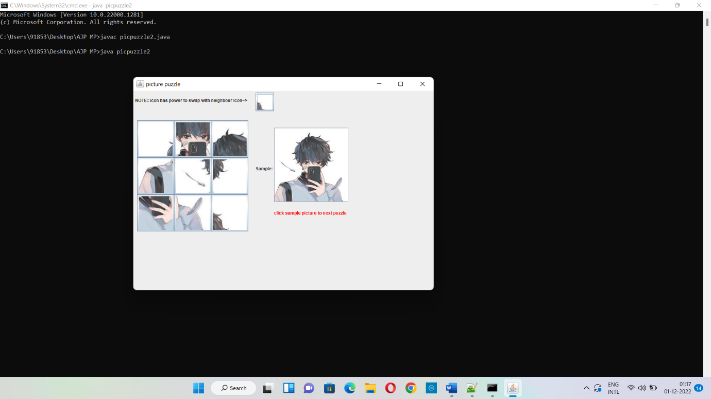

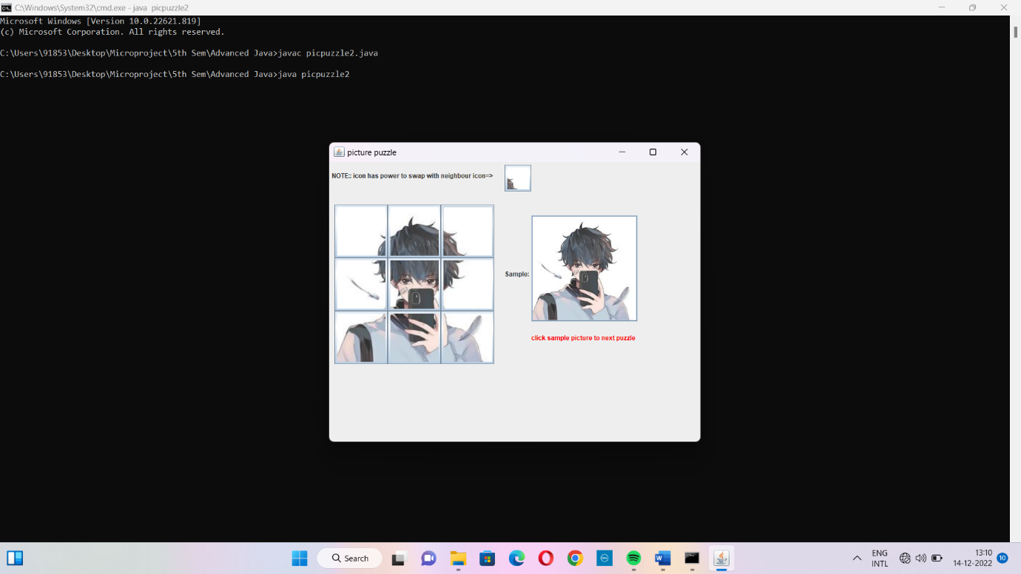

8.0 Skill developed /learning outcomes of this micro-project
We learnt how to create Pic Puzzle Game, we learnt how to use switch case and different operators in Java Programming Language.

Reference

Sr.no | Title of Book | Author
 | Complete Reference | Schidt,Herbert
 | Java 2 Programming Black Book | Holzner,Steven et al.

